Home School Timetable
Week 3  20.4.2020 | 9:00-9:30 | 9:30 -10.30 | 10.30 | 11:00 | 11.15-12.00 | 12.00 | 1.15-3.15
Monday  Dinosaurs | Joe Wicks  PE Lesson | Relaxation: Mindfulness colouring (dinosaurs)  Handwriting/Dinosaur Spelling  Emotional Literacy: Diaries – How am I feeling?  Literacy – write own dinosaur story | Story/Snack | Break | Cooking: Dinosaur fossil cookies  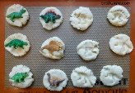  TT Rockstars-Timestables  Dinosaur puzzles  Freeze dinosaurs (free the dinosaurs) | Lunch | Gardening  Dinosaur hunt (Maths problems)  Art – Draw dinosaurs/create Jurassic world/Dinosaur jump and wash/make fossils  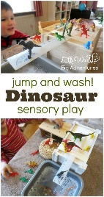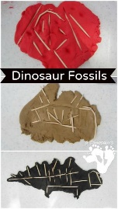
Tuesday | IN SCHOOL
Wednesday  Lego | Joe Wicks  PE Lesson | Relaxation: Mindfulness meditation  Emotional Literacy: Therapeutic Stories (Lego story)  Handwriting/Spelling (contractions with Lego)  Suffixes with Lego  Inside Out: Emotions – discuss the different emotions (characters in the film), their names and the colours associated with them. Scared memories | Snack/Story/Remember when…game (RP) | Break | TT Rockstars –Timestables  Measurement – build the world’s tallest Lego tower (measure) | Lunch | Reading and structured play (all): board games, emotion games, puzzles, role play.  Build a Lego treehouse for you and your friend  History – Romans. Create a fact sheet on the Romans/Build a Roman style home
Thursday  Lion King | Joe Wicks  PE Lesson | Relaxation: Lion King Yoga  Science: Research African animals and their habitats/diets  Literacy: Watch intro to film then create Lion King themed poems | Story/Snack | Break | Handwriting/Spelling  TT Rockstars –Timestables  Maths: Division and Multiplication sums to find the Lion King characters | Lunch | Reading (comprehension) and structured play: Lion King role play/make a story sack  Paint/draw Lion King stones  Africa Art (landscapes with animal silhouettes)
Friday  Electronics | Joe Wicks  PE Lesson | Relaxation: Art Therapy  Literacy: Write the prequel of ‘The Wild Robot’ /Write an information page on robots  Handwriting/Spelling  Circle time: I am thankful for…/Gratitude game | Story/Snack | Break | TT Rockstars –Timestables  Maths: Electronic cars – How far can they travel? | Lunch | Reading  Golden Mile/Cool down  Build a scalextrics track

Dinosaur fossil cookies
To make the cookies I made some cookie dough. I made some small flattened rounds of dough and placed them on a silicone mat. I pushed a dinosaur figurine into each one, gently rotating it slightly to try and get as many of the details imprinted into the dough as possible.
100g (4oz) | butter, softened
50g (2oz) | caster sugar
150g (5oz) | self-raising flour
Preheat the oven to 180°C /fan 160°C/ gas 4. Lightly butter two baking trays.
Measure the butter into a bowl and beat to soften. Gradually beat in the sugar and then the flour. Bring the mixture together with your hands to form a dough. Form the dough into 16 balls about the size of a walnut and place spaced well apart on the prepared baking trays. Dip a fork in a little water and use this to flatten the biscuits.
Bake in the preheated oven for 15–20 minutes until a very pale golden. Lift off the baking tray and leave to cool completely on a wire rack.

